Internet Protocols
The Internet Protocol (IP) is a protocol, or set of rules, for routing and addressing packets of data so that they can travel across networks and arrive at the correct destination. Data traversing the Internet is divided into smaller pieces, called packets. IP information is attached to each packet, and this information helps routers to send packets to the right place. Every device or domain that connects to the Internet is assigned an IP address, and as packets are directed to the IP address attached to them, data arrives where it is needed.
Once the packets arrive at their destination, they are handled differently depending on which transport protocol is used in combination with IP. The most common transport protocols are TCP and UDP.
An internet protocol defines two things:
- Format of IP packet
- IP Addressing system
What is an IP packet?
Before an IP packet is sent over the network, two major components are added in an IP packet, i.e., header and a payload.
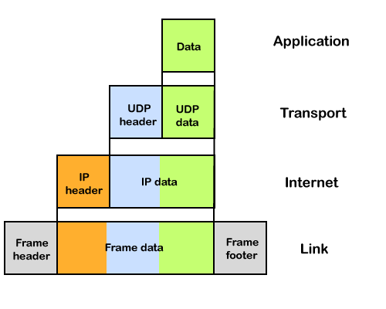
An IP header contains lots of information about the IP packet which includes:
- Source IP address: The source is the one who is sending the data.
- Destination IP address: The destination is a host that receives the data from the sender.
- Header length
- Packet length
- TTL (Time to Live): The number of hops occurs before the packet gets discarded.
- Transport protocol: The transport protocol used by the internet protocol, either it can be TCP or UDP.
There is a total of 14 fields exist in the IP header, and one of them is optional.
Payload: Payload is the data that is to be transported.

